DevOps Traning

1. Type of applications

Desktop,Web and Interprise Application

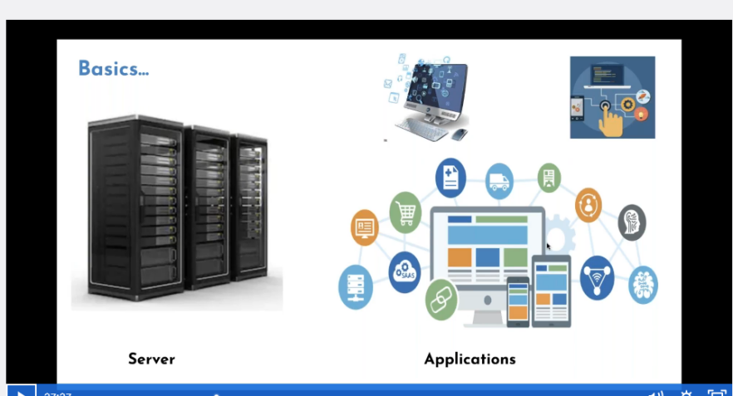

1. Monolithic and 3Tier Architechitecture

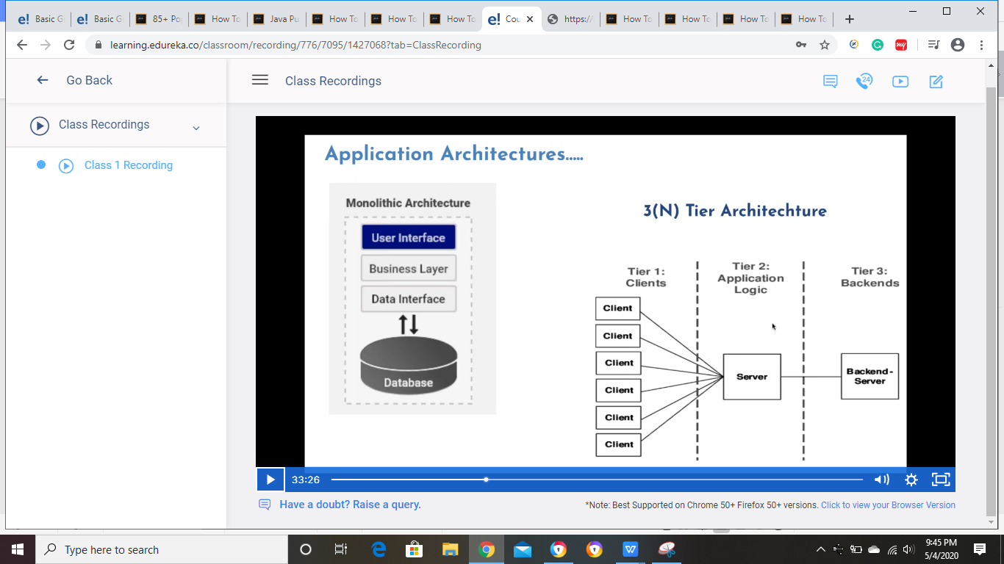

1. Agile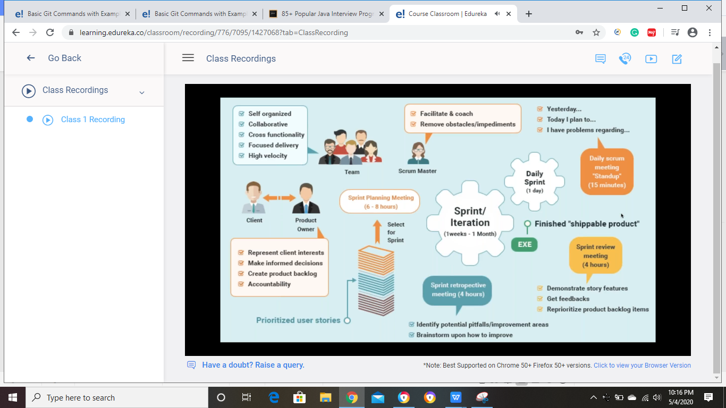



1. IT Evealution

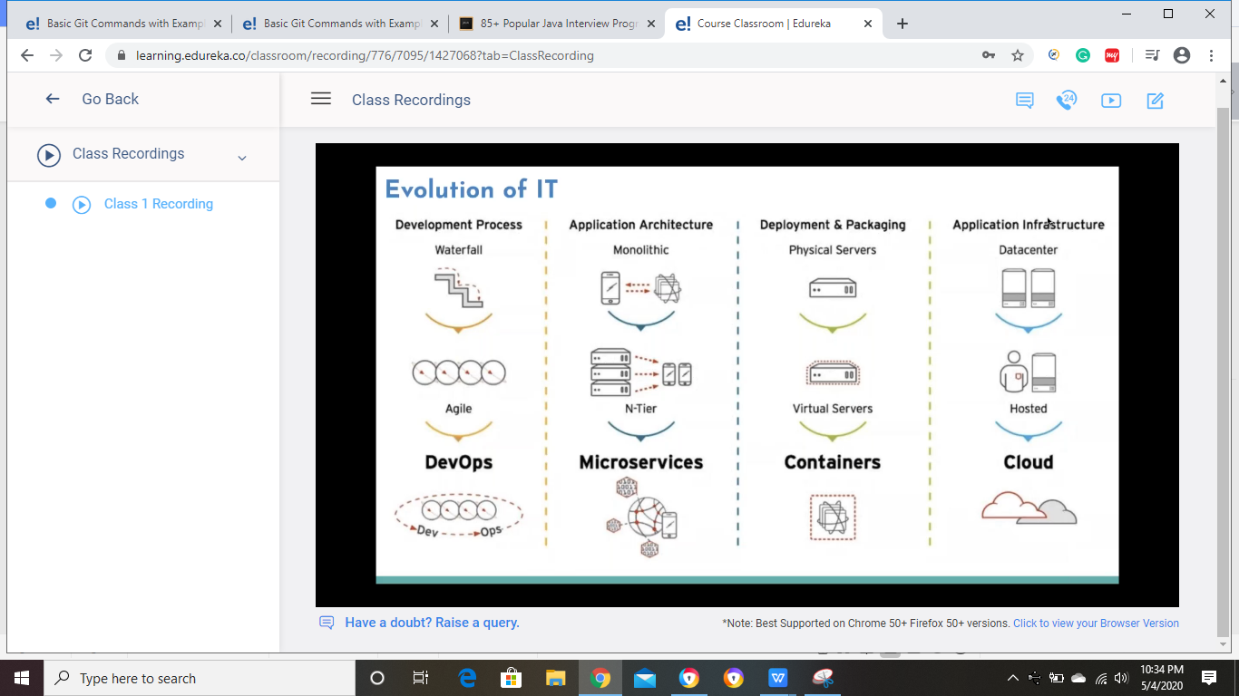

V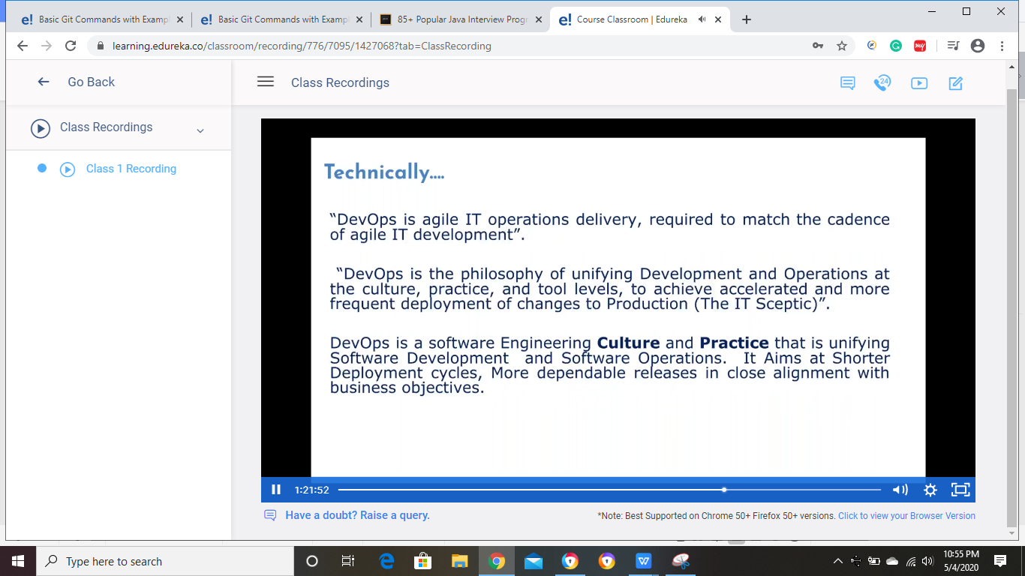

1. Version Control

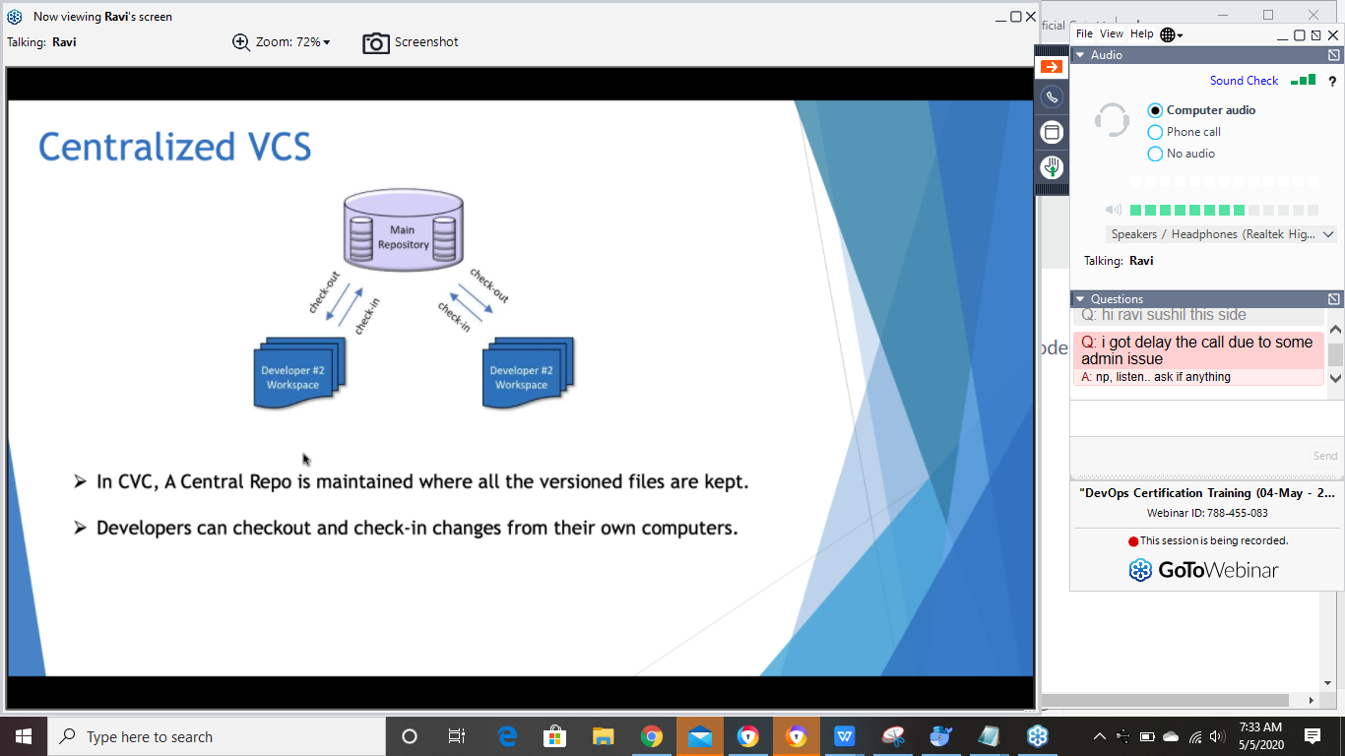

CREATE INSTANCE on AWS and GoggleCloud

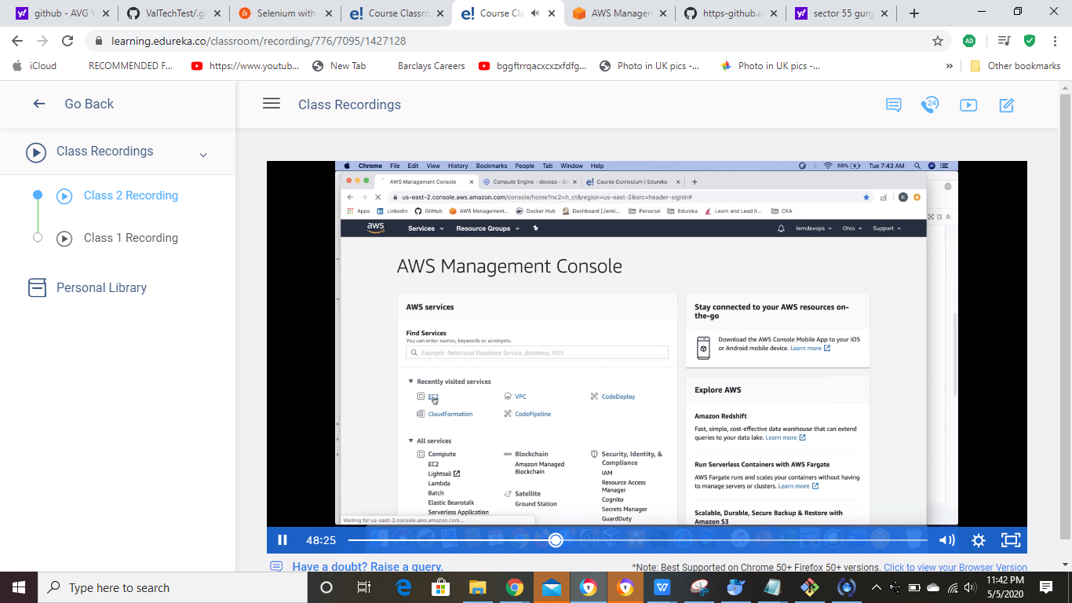

Running instance

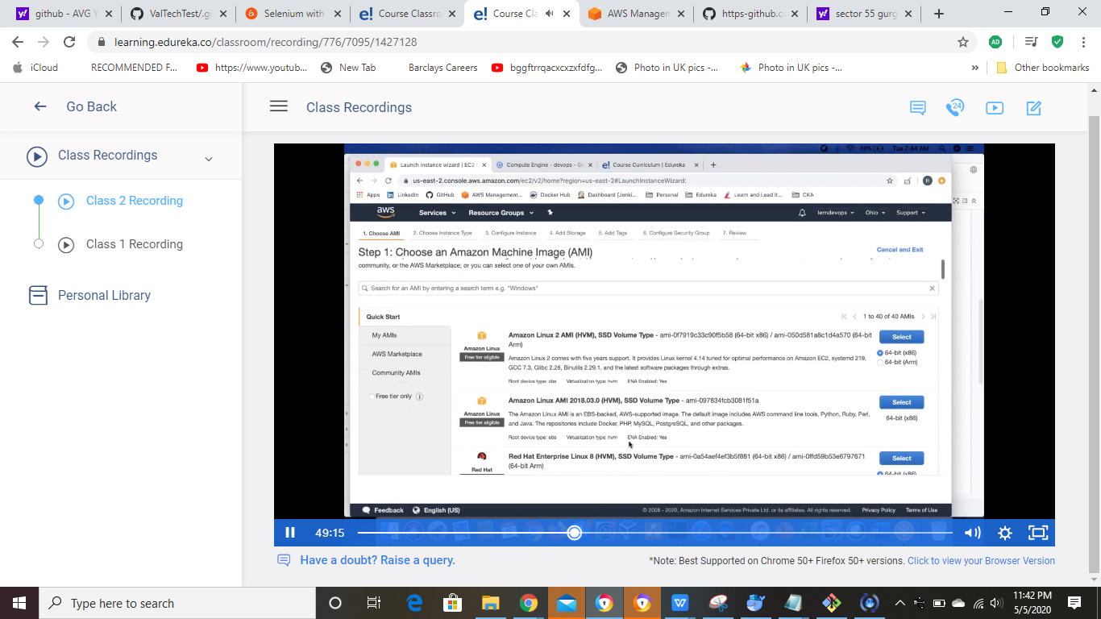

Go to Ubunto

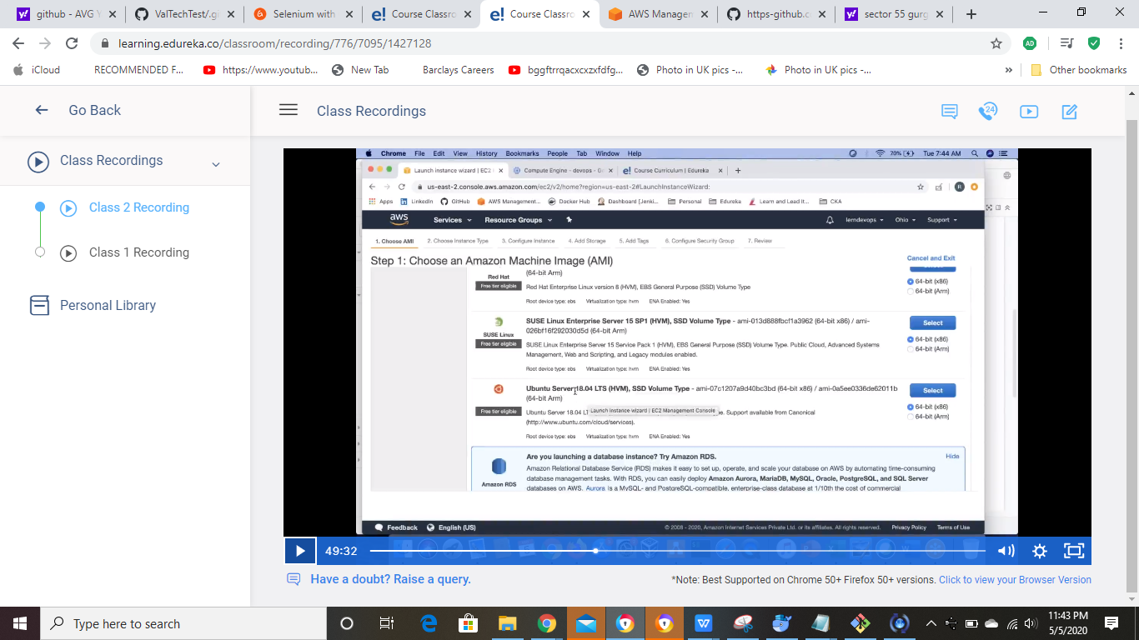

Select Free Trial intance type



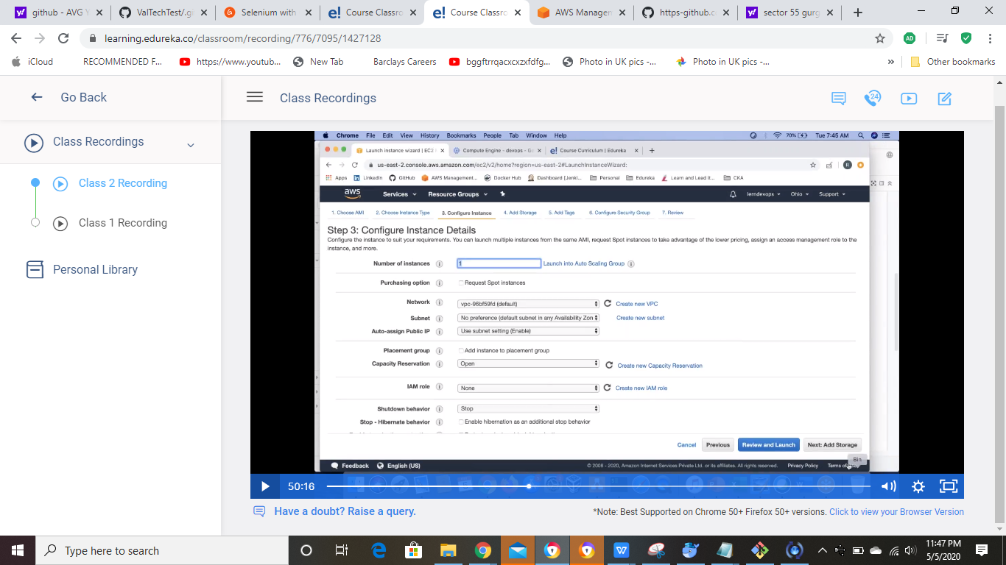

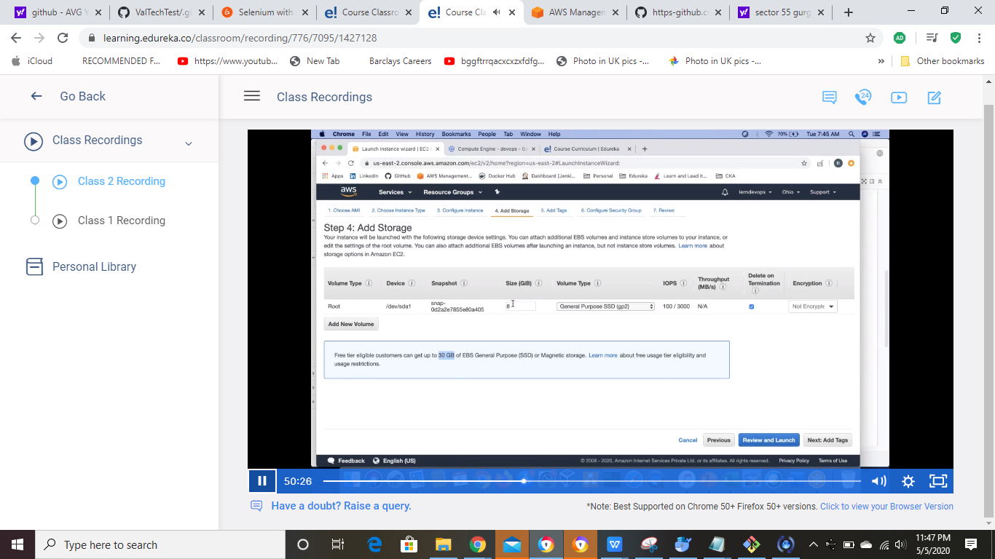

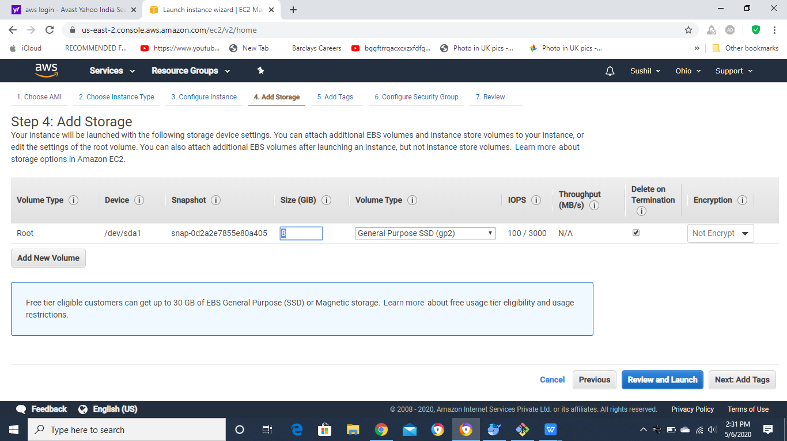

Next

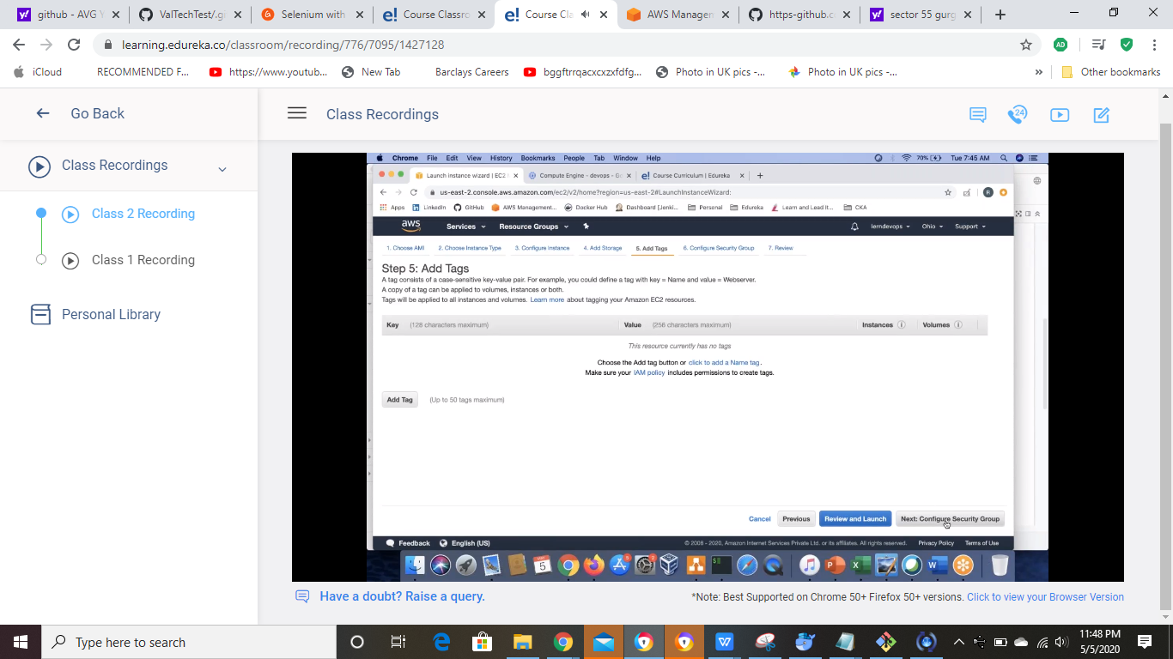

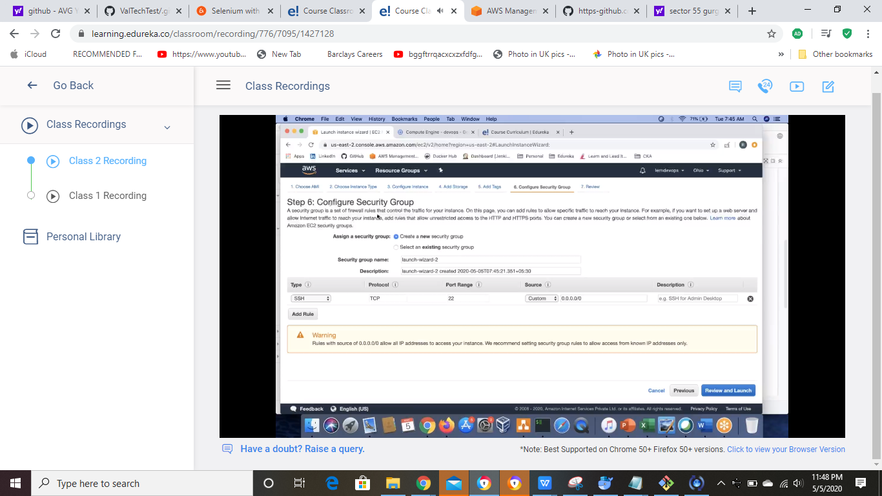

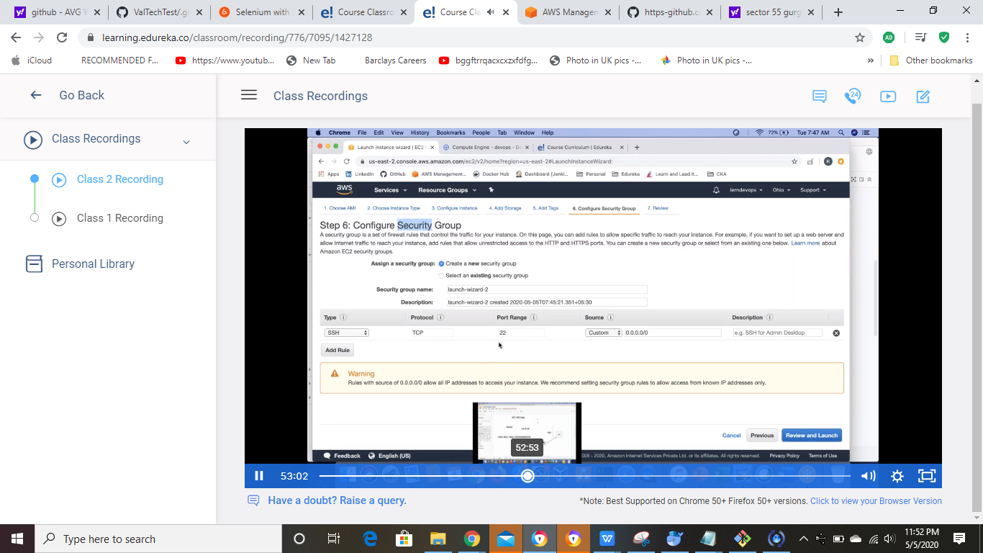

Eneter name and clcik on add rules and select All traffic and anywhere option

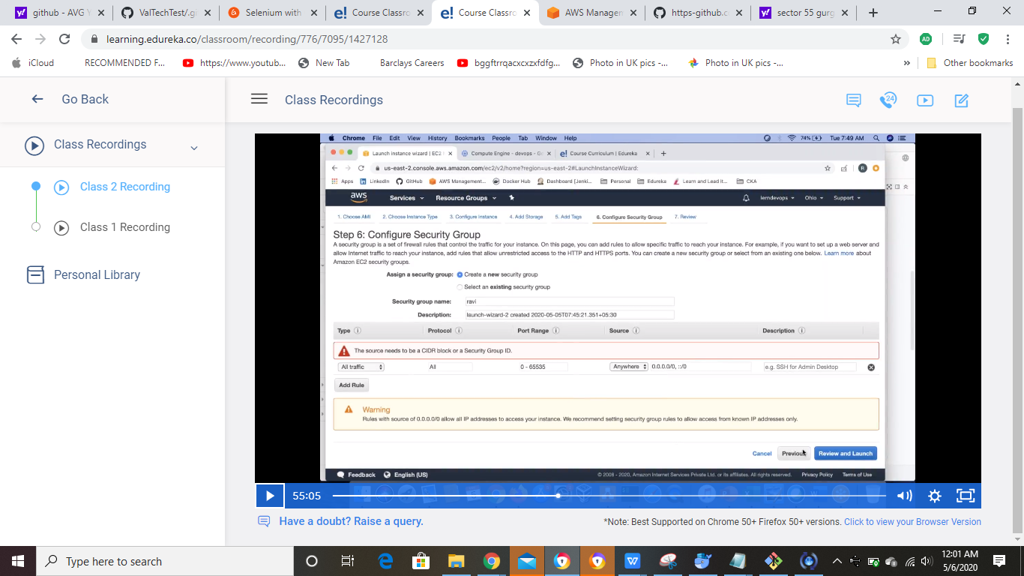

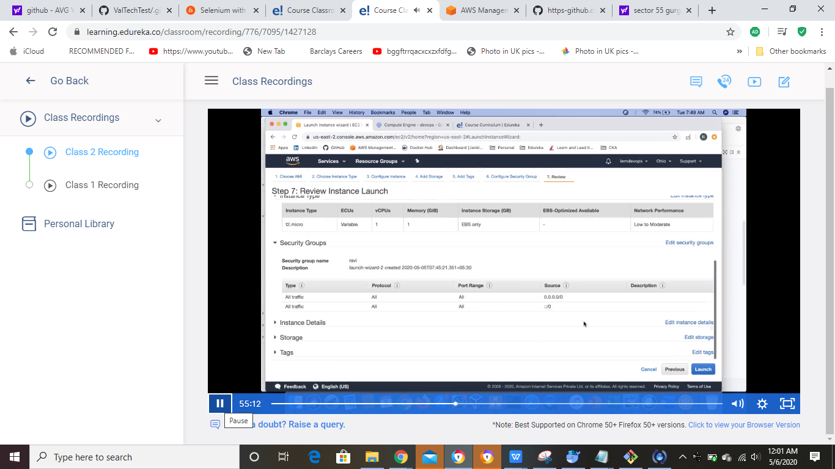

Lunch it

Enter the key pair name

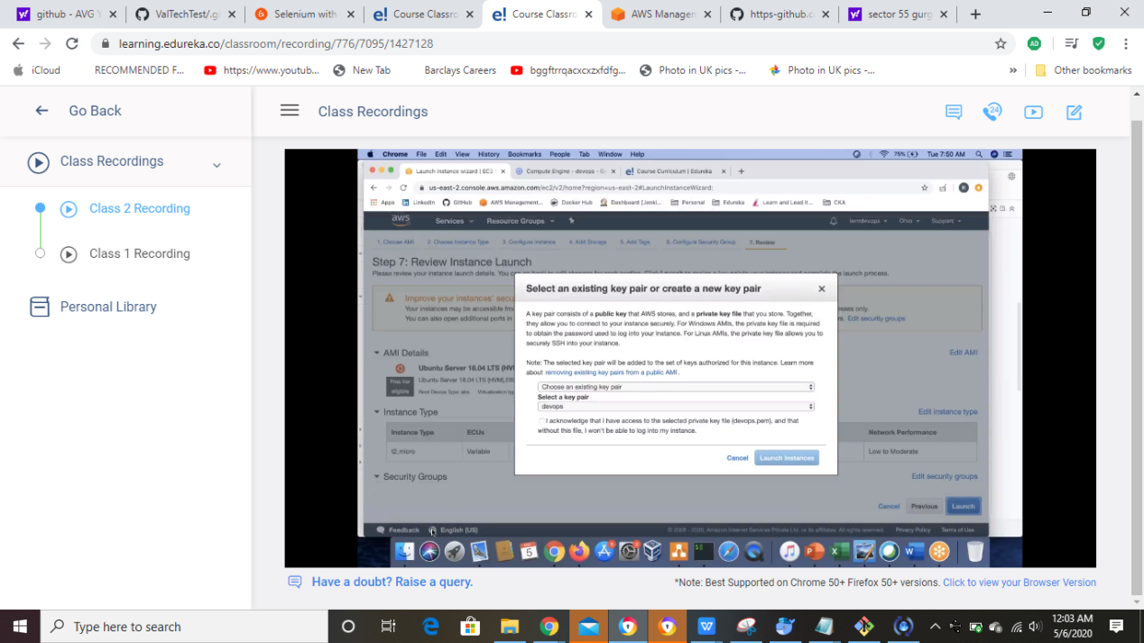

Create new key pair and clik on download and once downloaded the launch it

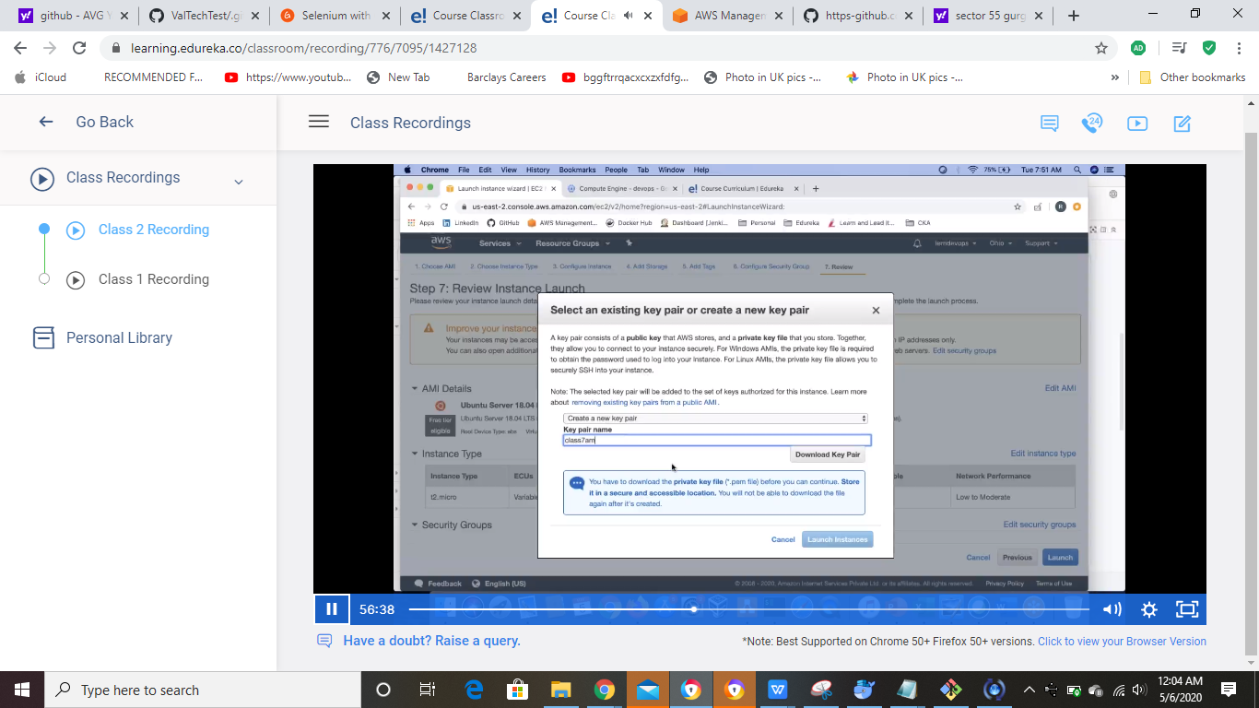

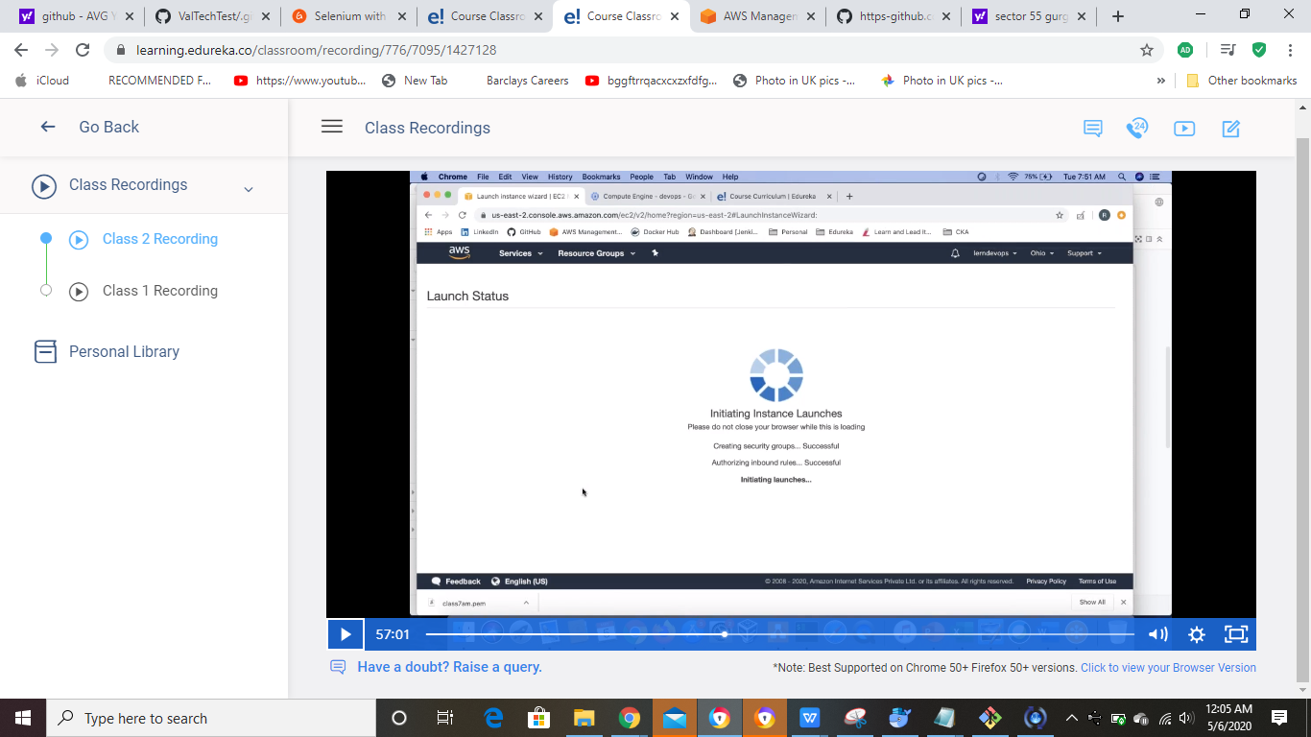

How to commect with AWS machine

**Ubuntu** is default username if connect with Ubuntu

Public ip address

How to connect the created machine

Got GITBash

Open the GitBash and go the folder where keys pair exists(yellow color is for typed command)

Dell User@DESKTOP-8R9F2IH MINGW64 ~/Desktop/Edureka/Keys (master)

$ chmod 400 myNewInstanceMachine.pem

Dell User@DESKTOP-8R9F2IH MINGW64 ~/Desktop/Edureka/Keys (master)

$ ssh -i myNewInstanceMachine.pem

usage: ssh [-46AaCfGgKkMNnqsTtVvXxYy] [-B bind_interface]

[-b bind_address] [-c cipher_spec] [-D [bind_address:]port]

[-E log_file] [-e escape_char] [-F configfile] [-I pkcs11]

[-i identity_file] [-J [user@]host[:port]] [-L address]

[-l login_name] [-m mac_spec] [-O ctl_cmd] [-o option] [-p port]

[-Q query_option] [-R address] [-S ctl_path] [-W host:port]

[-w local_tun[:remote_tun]] destination [command]

Dell User@DESKTOP-8R9F2IH MINGW64 ~/Desktop/Edureka/Keys (master)

$ ssh -i myNewInstanceMachine.pem ubuntu@18.222.145.142

The authenticity of host '18.222.145.142 (18.222.145.142)' can't be established.

ECDSA key fingerprint is SHA256:UMNGtIhPFByMBGKszRa/dEFEHuWZP1iakuM7v4cUBNE.

Are you sure you want to continue connecting (yes/no)? yes

Warning: Permanently added '18.222.145.142' (ECDSA) to the list of known hosts.

Welcome to Ubuntu 18.04.4 LTS (GNU/Linux 4.15.0-1065-aws x86_64)

* Documentation: https://help.ubuntu.com

* Management: https://landscape.canonical.com

* Support: https://ubuntu.com/advantage

System information as of Wed May 6 09:35:06 UTC 2020

System load: 0.0 Processes: 88

Usage of /: 13.7% of 7.69GB Users logged in: 0

Memory usage: 15% IP address for eth0: 172.31.41.208

Swap usage: 0%

0 packages can be updated.

0 updates are security updates.

The programs included with the Ubuntu system are free software;

the exact distribution terms for each program are described in the

individual files in /usr/share/doc/*/copyright.

Ubuntu comes with ABSOLUTELY NO WARRANTY, to the extent permitted by

applicable law.

To run a command as administrator (user "root"), use "sudo <command>".

See "man sudo_root" for details.

ubuntu@ip-172-31-41-208:~$ cat /etc/os-release

NAME="Ubuntu"

VERSION="18.04.4 LTS (Bionic Beaver)"

ID=ubuntu

ID_LIKE=debian

PRETTY_NAME="Ubuntu 18.04.4 LTS"

VERSION_ID="18.04"

HOME_URL="https://www.ubuntu.com/"

SUPPORT_URL="https://help.ubuntu.com/"

BUG_REPORT_URL="https://bugs.launchpad.net/ubuntu/"

PRIVACY_POLICY_URL="https://www.ubuntu.com/legal/terms-and-policies/privacy-policy"

VERSION_CODENAME=bionic

UBUNTU_CODENAME=bionic

ubuntu@ip-172-31-41-208:~$ ^C

ubuntu@ip-172-31-41-208:~$

Once work done just delete the instance

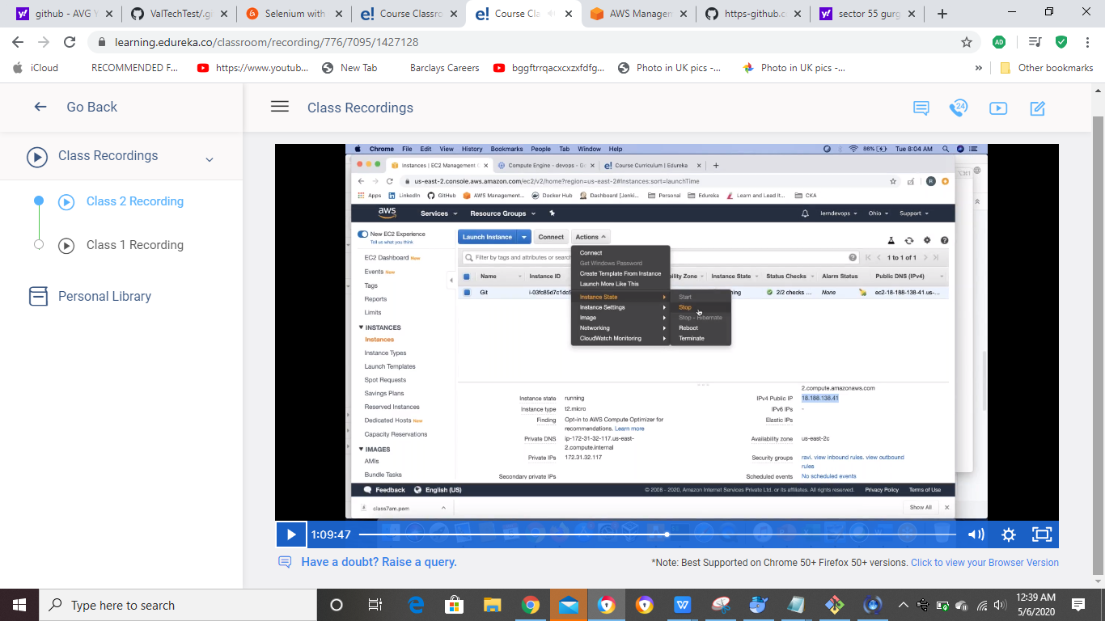

GCP

Services->Compute engine->VM instances->Create Intance

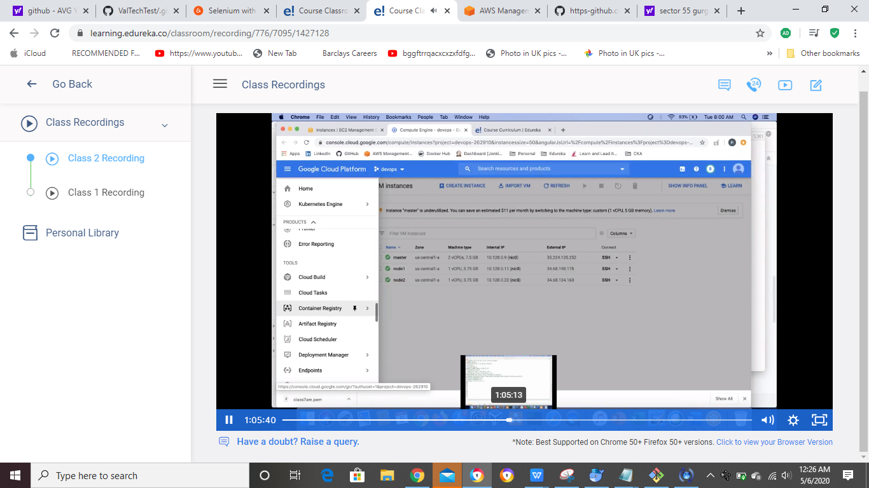

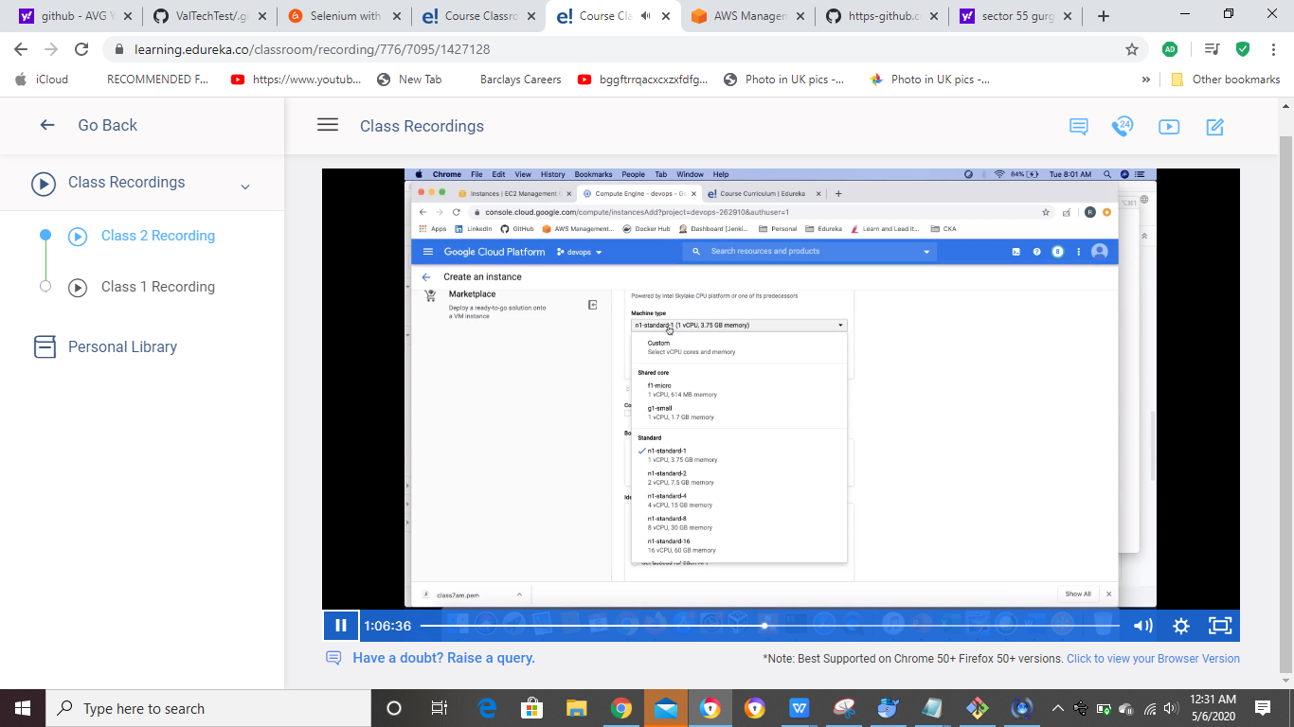

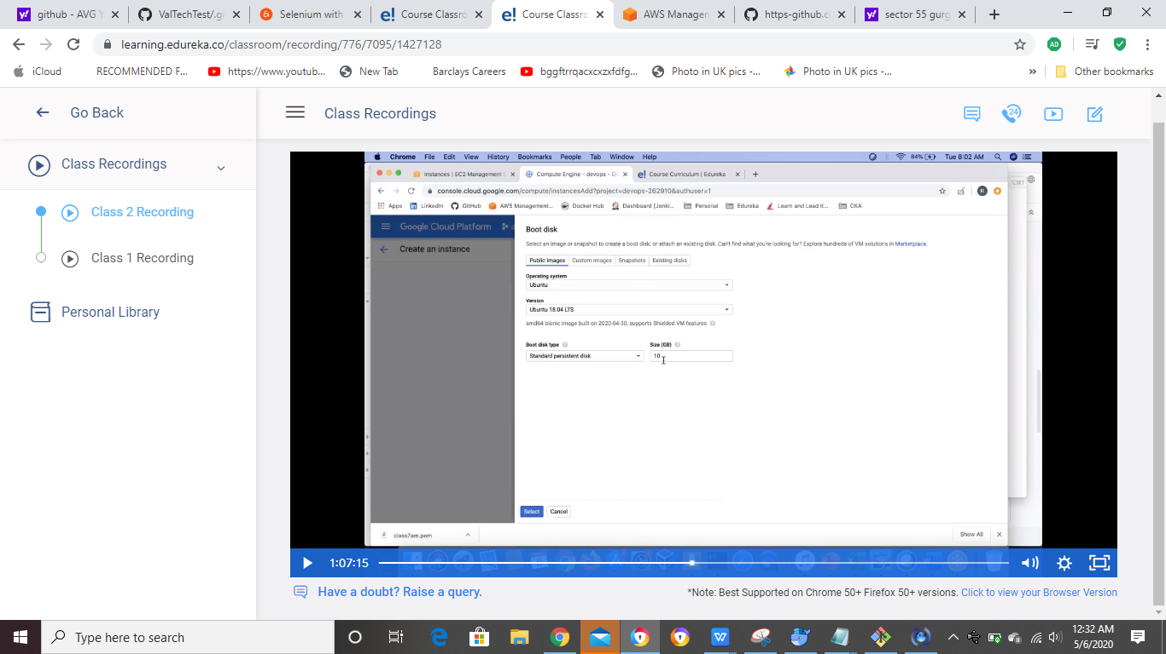

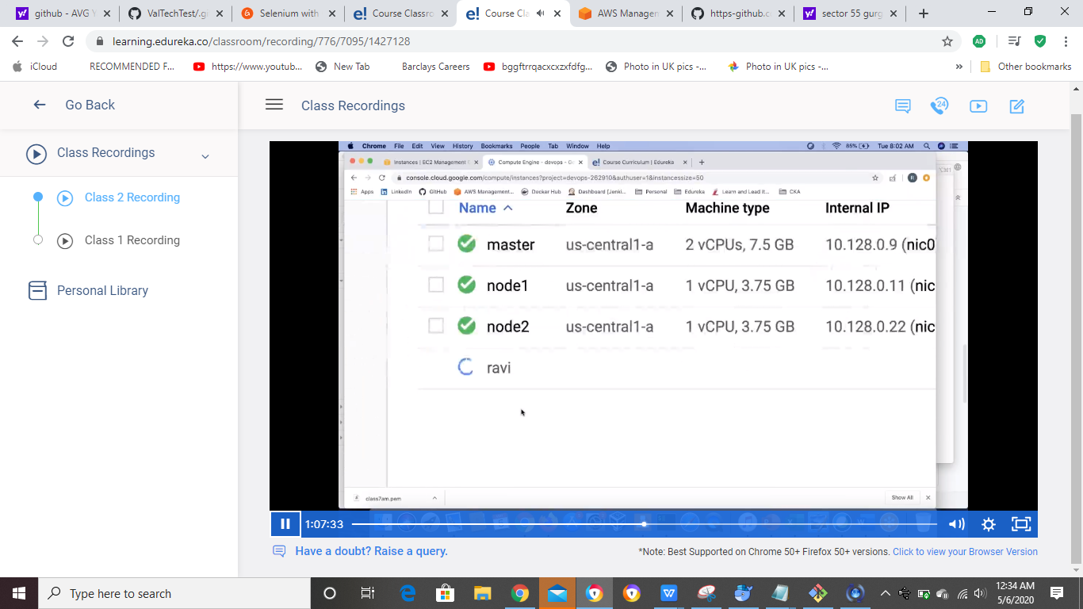

To connect clik the SSH,Terminal will launch

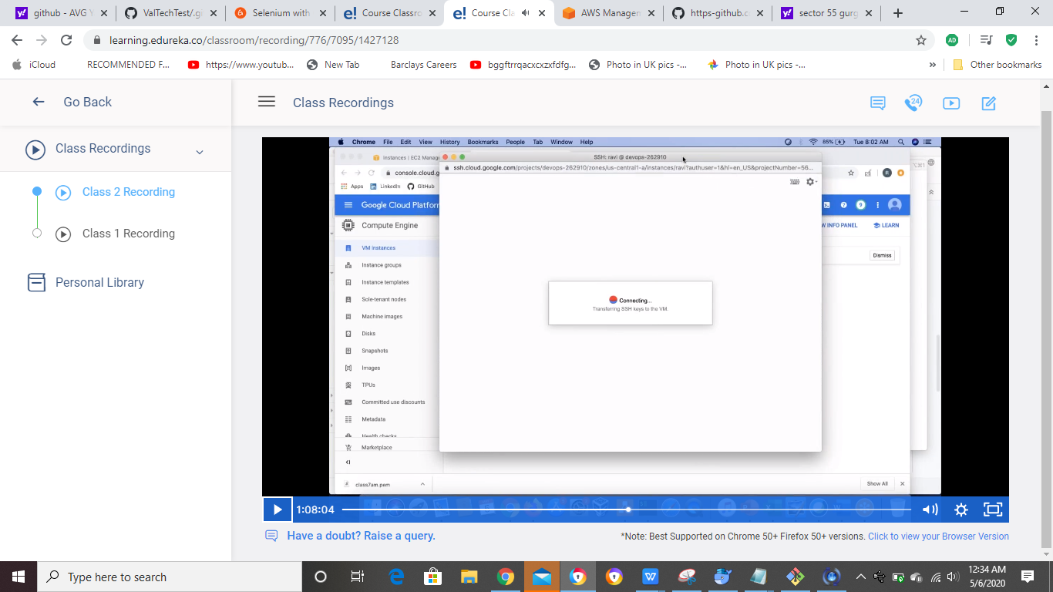

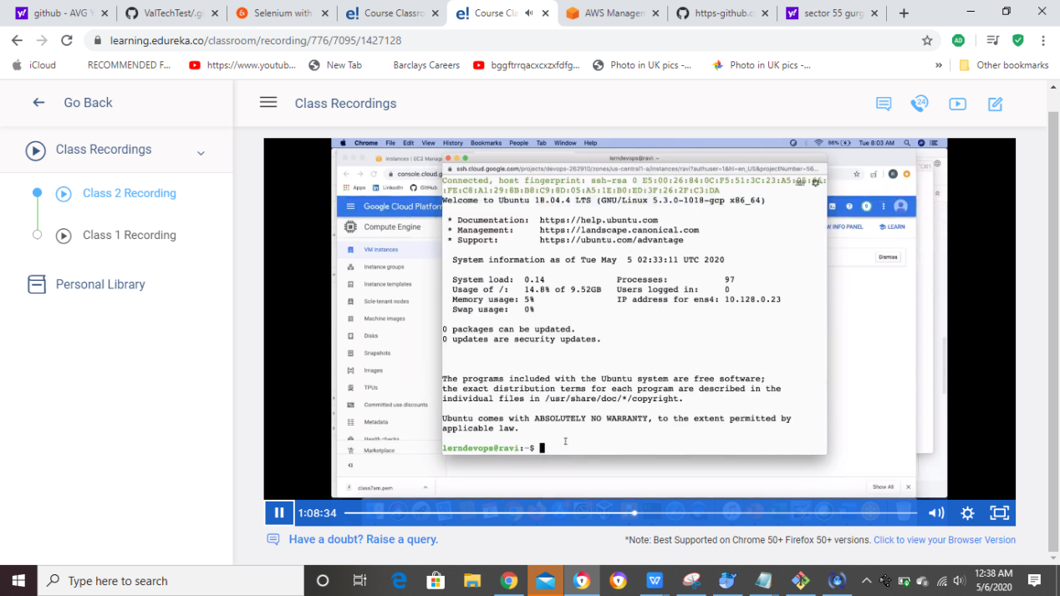

Once job done , delete it